1. Based on your experience as a QA.

a) SDLC (Software Development Life Cycle) namely the stages of developing a software. and SLDC is a pattern taken to develop a software system, which consists of stages (planning, design, implementation, testing and maintenance).

While STLC (Software Testing Life Cycle) are the stages in testing a software. the stages of the testing process carried out in a systematic and planned manner. In the STLC process, various activities are carried out to improve product quality.

When making a software, the most important thing is to understand the business flow of a product to be made, detailing what needs will be done by the developer team. if the software itself has been designed and made by the developer, a QA will do a tester and make sure the product is safe for users to use.

b) As a QA Engineer, you must be able to test a software/website that has been created by the developer. when a QA finds a Cycle bug the steps to take are:

1. (Review) when the tester finds a bug and makes a report about the bug, then the bug will be reviewed again before being implemented that the bug is true and needs to be followed up. if there is a bug a tester will report one of them using trello. trello there is as much detailed information as possible, namely Title, Description of Bug/Issues, presconditon, actual, expected.

2. (Rejected) Condition when a bug report that has been reviewed and deemed necessary to be checked further (needs to be tested or further research done) to be reported back later. It could also be that the bug report was rejected.

3. (Open) The bug report has been reviewed and its existence has been proven true, so the status has changed to open. After that, there will be a follow-up that determines which stage the bug will go to.

4. (Assigned) The team will assign the development department to fix the bug.

c) Real Case about Severity and Priority:

=> A very low severity with a high priority: A logo error for any shipment website, can be of low severity as it not going to affect the functionality of the website but can be of high priority as you don’t want any further shipment to proceed with the wrong logo.

=> A very high severity with a low priority: Likewise, for flight operating website, a defect in reservation functionality may be of high severity but can be a low priority as it can be scheduled to release in a next cycle.

d. Equivalence Partitioning is a type of black box testing technique in which the input data units are divided into equivalent partitions that can be used to derive test cases to reduces the time required for testing because of the small number of test cases.

Boundary Value Analysis testing is used to identify errors at boundaries rather than finding those that exist in the centre of the input domain.

2.

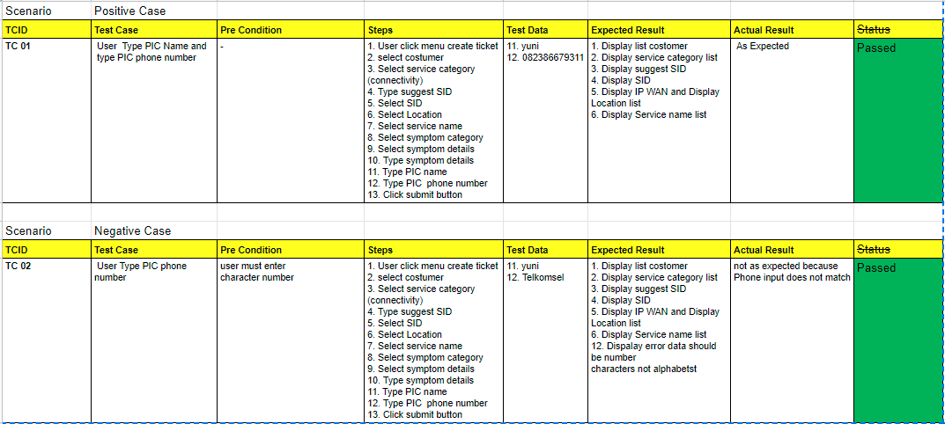

3. A. A test scenario can ensure that all test is covered by listing all possible positive and negative cases.

B. Defect Report:

1. Title: Issue on choosing coffee flavor syrup

=> Description: The coffee flavor syrup can be added only when the sugar is 3 units.

=> Actual result: User not able to add coffee flavor syrup when choosing other than 3 units of sugar.

=> Expected result: User able to choose any coffee flavor syrup when choosing any units of sugar.

2. Title: Issue on coffee temperature

=> Description: The coffee temperature does not the criteria; below than 78%.

=> Actual result: User is able to make a coffee when the temperature is below than 78%.

=> Expected result: The coffee machine will hold on a few second until reach temperature more than 78% before the user able to proceed to other step.

4. a) MockApi is creating its own edpoint, request body and response itself statically (without developing). MockAPI is a simple tool that lets you easily mock up APIs, generate custom data, and preform operations on it using RESTful interface. MockAPI is meant to be used as a prototyping/testing/learning tool. While realApi, the data is dynamic and has been developed.

b) Some defects will appear such as functionality bugs, reliability bugs, performance bugs and security bugs.